Senior Care Kits

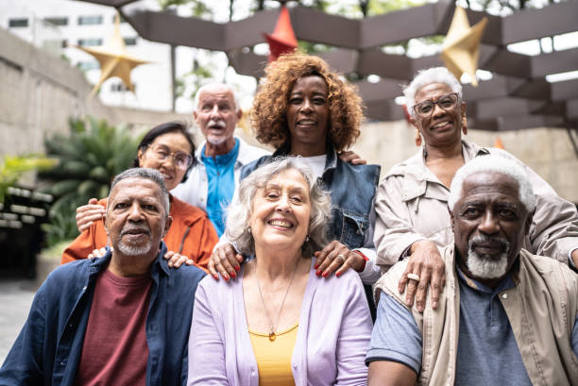

Senior kits are care packages thoughtfully assembled by volunteers to support older adults in our community. These kits include a variety of helpful and comforting items meant to brighten someone's day and provide a sense of connection. Whether it's practical supplies or small touches of kindness, these kits help remind recipients that they are valued and not alone. Volunteers play a meaningful role in spreading care and compassion through this simple yet powerful gesture. In just a few short minutes, you can create a heartfelt kit to make the day of seniors in Northeast Florida.

What to do:

- Add the following to each bag

- Lotion
- Magnifying Card
- Jar Grip
- Chapstick
- Pen
- Notepad
- 2 Tea Bags
- 4 Pieces Candy
- Small bag for candy and tea
- Pill Case
- Activity Book
- Pair of Grip socks
- 1 heartfelt card (see following instructions)

- Decorate the card: You can use the stencils, markers, images etc. to create decorations that include encouraging phrases, jokes, images; anything you’d like! It is a good rule of thumb to stay away from anything overtly religious as it will be impossible to know the culture and belief system of the individual who will receive the care bag. The following are available to help you:

- Images to cut out and glue sticks to adhere to the card
- Stencils
- Markers (to use with stencils or to use freehand!)
- Stickers
- Stamps

Here are some examples of cards that were created for a similar project:
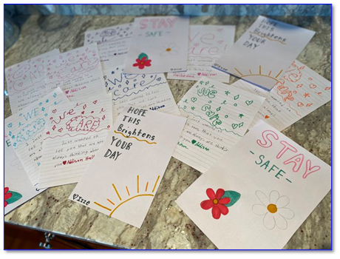

Place card inside the bag with the rest of the senior kit items.

