School Supply Drive
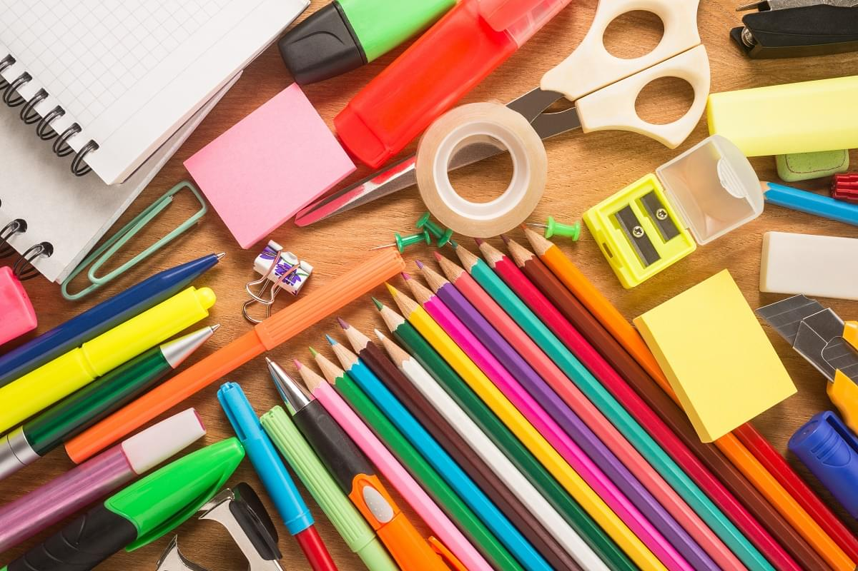

Most needed classroom items

- Pencils
- Colored Pencils
- Red pens
- Blue pens
- Black pens
- Crayons
- Markers
- Glue sticks
- Glue Bottles
- Scissors
- Highlighters
- Erasers
- Loose leaf notebook paper—College ruled
- Loose leaf notebook paper—wide ruled
- Graph paper
- Spiral notebooks
- Composition books
- Pocket folders
- Dividers
- index cards
- Calculators
- Rulers
- Compasses
- Clear or mesh backpacks
- Lunchboxes
- Pencil pouches
- Tissues
- Hand sanitizer
- Dry erase markers
- Plastic zip bags
- 3-ring binders
- Pencil boxes
- Flash drives
- Head phones

