**​​**

**C.R.O.W.N. Kits**



**​Creating a Respectful and Open World for Natural Hair​**

​​Full Service Schools (FSS) of Jacksonville is a neighborhood-based collaboration designed to remove barriers to a child’s academic success. Through this initiative, United Way and its partners connect nearly 3,500 students and families to a critical range of therapeutic, health and social services. Each FSS site strives to meet the specific needs of the neighborhood in which it is based by providing a number of free services including:

​Behavior help for children Individual/family counseling  Mentoring  Parenting help  After-school tutoring  Case management  Enrichment activities  Medical/health services  Health care enrollment  (they also provide neighborhood grants!)

​Increasingly, many children within the 88 schools within the FSS network, in grades kindergarten to high school, are living in displaced homes (i.e., living with relatives, hotels or in shelters) and do not have regular access to basic hygiene products, and haircare items for Black hair are frequently overlooked when toiletry items are donated. Not all haircare products meet the unique needs of the Black community, and many social services organizations have difficulty providing these necessary items. Moreover, this lack can reinforce stereotypical Eurocentric aesthetic ideals in students, who need to be reassured that Black hair is absolutely beautiful, too.

​​

**​​What to do: ​**

* ​​**Decorate a white paper sack**: You can use the stencils, markers, images etc to create decorations that include encouraging phrases, jokes, images; anything you’d like! It is a good rule of thumb to stay away from anything overtly religious as it will be impossible to know the culture and belief system of the student who will receive the snack pack. The following are available to help you:
* ​Images to cut out and glue sticks to adhere to the sack
* ​Stencils
* ​Markers (to use with stencils or to use freehand!)

​

* **​In each sack, add the following**:

​

* ​1 comb
* ​1 bottle shampoo
* ​1 bottle conditioner
* ​1 bottle hair oil/treatment
* ​1 shower cap
* ​1 Lotion
* 1 Spray bottle

​

​

* **​Write and decorate an encouraging card!**
* ​Cards can be decorated with the same materials used for the paper sacks

​Here are some examples of cards that were created for a similar project:

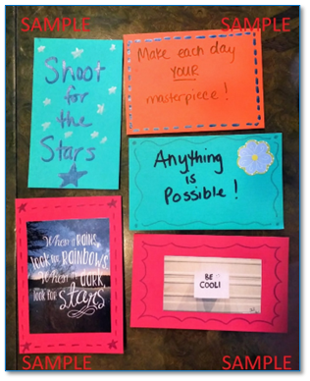

**​Place card in bag with other C.R.O.W.N. kit items and you’re finished!**