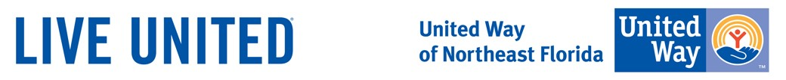

Food Drive

Pre-Project Discussion:
- Did you know that more than 1 in 5 kids in the United States don’t know where their next meal is coming from?
- Did you food insecurity can have a direct impact on general health? Food insecurity can be related to a range of different health problems including diabetes, depression and heart disease. Having enough healthy food to eat can literally save people’s lives.

What You Need:
- A large box(s) to collect food
- Poster Board, images and markers to create signs
- Arrange for transportation to deliver the collected food to the local shelter

Steps:
- Contact your project coordinator for this need to discuss your interest and timeline.
- Arrange with all members of your family, team or office to promote this drive.
- Create your collection box and sign. Make sure your box is large enough to hold the donated food.
- Tip: Younger volunteers can help decorate posters and collection boxes or help sort the donated food by type.
- Have fun and remember all the families and individuals you are helping!

Reflection Questions:
- How did your feelings about hunger change?
- How did this project impact the quality of life of individuals in your community?
- How did this project impact your family?
- What did you notice about the community's reaction to your project?

Full Service School Food Drive

Full Service Schools sites need food donations throughout the year, though the most critical need comes during the summer months, when children do not have access to the free breakfasts and lunches provided by schools. All food donations will be used in food pantries at various Full Service School sites and will enable FSS to provide food to the students and families living in the neighborhoods near each FSS Resource site.

Suggested Items

The following is a list of the most needed items at Full Service School pantries:
- Easy-to-open, single serving food items that only require a microwave and water to cook, i.e. Easy Mac, Cup of Noodles, Oatmeal, etc. (with paper tab openings). (This allows younger children to be able to prepare and eat without supervision).
- Dried legumes (beans, lentils, peas)
- Crackers (such as Ritz or Keebler)
- Nuts, raisins or other dried fruit
- Pasta sauce and/or canned crushed or diced tomatoes)
- Peanut butter
- Dried pasta
- Flour (white, whole wheat)
- Seasonings (vanilla, salt, pepper, paprika, cinnamon, pepper, taco seasoning, etc.)
- Sugar (White or Brown)
- Bouillon cubes or granules (chicken, vegetable, beef)
- Honey and/or fruit jams
- Jell-O or pudding mixes
- Whole grains (barley, bulgur, cornmeal, couscous, oats, quinoa, rice, wheat berries)
- Plant-based oil (corn oil, vegetable oil, coconut oil, olive oil)
- Cereal
- Grits
- Potato Chips, Sun Chips, Nacho Chips or Tortilla Chips
- Cookies
- Popcorn (bagged, not microwavable)
- Instant potato flakes and/or easy to prepare pasta sides
- Packaged meals (macaroni and cheese, hamburger helper, Rice-A-Roni, Ramen noodles, etc.)
- Fruit juices, teas, coffee, drink mixes
- 100% fruit juices in single serving boxes
- Gummies
- Granola bars (all kinds, soft, hard, breakfast, snack…)
- Other healthy Snacks for kids….
- Reusable grocery bags (Very useful for families taking back food from the pantries!)
Please avoid donating items packaged in glass as these can break and be dangerous.

