**​​**

**Confidence Kits**

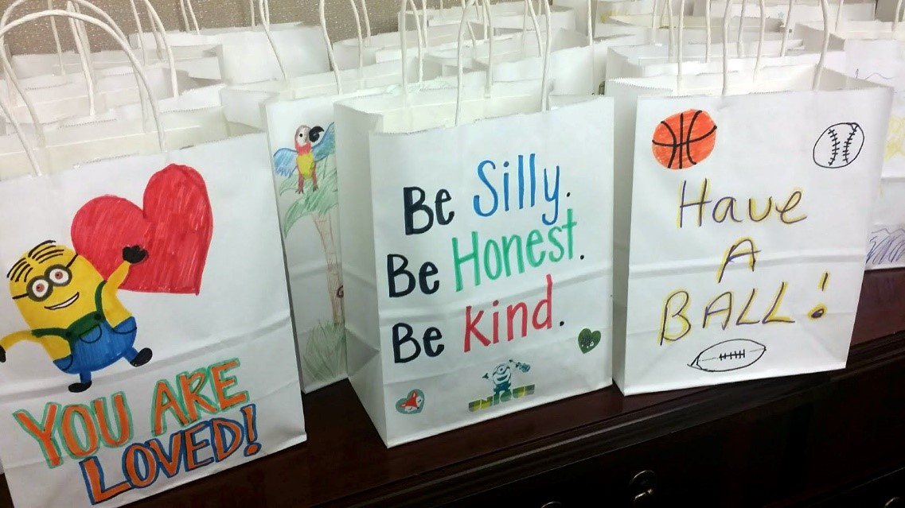

​​Full Service Schools (FSS) of Jacksonville is a neighborhood-based collaboration designed to remove barriers to a child’s academic success. Through this initiative, United Way and its partners connect nearly 3,500 students and families to a critical range of therapeutic, health and social services. Each FSS site strives to meet the specific needs of the neighborhood in which it is based by providing a number of free services including:

​Behavior help for childrens Individual/family counseling s Mentoring s Parenting help s After-school tutoring s Case management s Enrichment activities s Medical/health services s Health care enrollment  (they also provide neighborhood grants!)

​Increasingly, many children within the 88 schools within the FSS network, in grades kindergarten to high school, are in households that struggle financially and do not have regular access to food and basic hygiene products.  Feminine products are ineligible for coverage under food stamps and SNAP benefits, contributing to what is called “period poverty”.  In the US, nearly 1 in 5 girls have missed school because they lack access to feminine products, which leads to embarrassment and lack of self-esteem.  Furthermore, if a girl has to stay home every time she has her period, she will fall behind her classmates by 145 days.  Consistent school absences lead to a drop in grades and performance, which will have lasting repercussions in these student’s lives.  By providing these items, these girls will have one less thing to worry about and be able to focus on what is really important – their education!

**What to do:**

* **Decorate the paper sack**:

 You can use the stencils, markers, images etc. to create decorations that include encouraging phrases, jokes, images--anything you’d like!*It is a good rule of thumb to stay away from anything overtly religious as it will be impossible to know the culture and belief system of the student who will receive the snack pack*. Suggested items to decorate with are:

* Positive Images to cut out and glue/glue sticks to adhere to the card
* Stencils, stickers and/or stamps
* Markers, colored pencils or paint

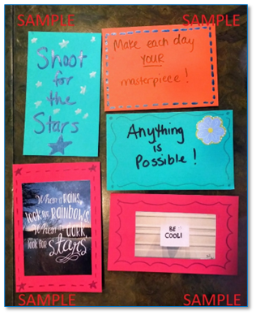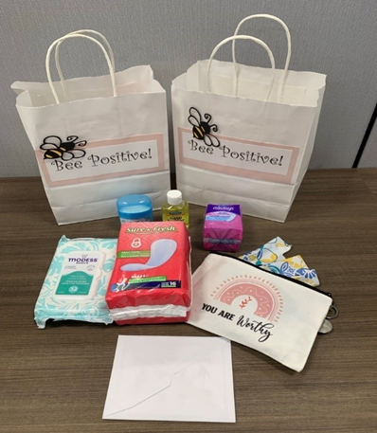

**In each provided decorated sack, add the following**

* Deodorant
* 1 pack maxi pads
* Packet of tampons/ 5 Tampons*
* *Canvas bag to hold wipes and Tampons
* 1 pack pantiliners
* 3 Personal wipes*
* 1 mini-bottle hand sanitizer

Add all items to a decorated bag along with a card, and you’re finished!